**Google Cyber Security Course Activity**

**File permissions in Linux**

Project description

I got practical experience in using basic Linux bash shell commands to

* **Examine file and Directory permissions**
* **Change permissions on file**
* **Change permissions on directories**

I had also learned to delete, create, move, copy files and directories with the Linux commands in previous lessons as well.

The research team at my organization needs to update the file permissions for certain files and directories within the projects directory. The permissions do not currently reflect the level of authorization that should be given. Checking and updating these permissions will help keep their system secure. To complete this task, I performed the following tasks:

Check file and directory details

For checking the files and directory details I first navigate to Projects Directory, current working directory is /home/reasearcher2

Linux command - ~$ cd projects

~/projects$ ls

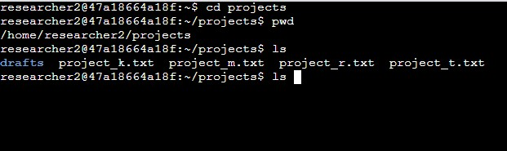

The first line of the screenshot displays the command I entered, and the other lines display the output. The code lists all contents of the projects directory. I used the ls command with the -la option to display a detailed listing of the file contents that also returned hidden files. The output of my command indicates that there is one directory named drafts, one hidden file named .project_x.txt, and five other project files. The 10-character string in the first column represents the permissions set on each file or directory.

Describe the permissions string

Now for checking the permissions for all the files and directories inside the project directory I’ll follow with the command

The following command will show all the unhidden files and directories permissions

Linux command - ~/projects$ ls –l

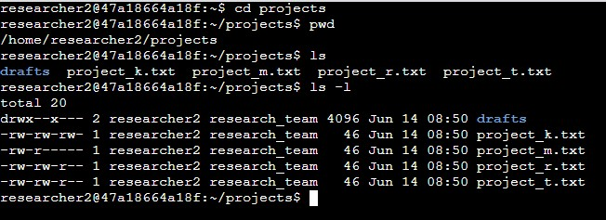

For example, the file permissions for project_t.txt are -rw-rw-r--. Since the first character is a hyphen (-), this indicates that project_t.txt is a file, not a directory. The second, fifth, and eighth characters are all r, which indicates that user, group, and other all have read permissions. The third and sixth characters are w, which indicates that only the user and group have write permissions. No one has execute permissions for project_t.txt.

Change file permissions

In the /home/researcher2/projects directory, there are five files with the following names and permissions:

1. project_k.txt

* User = read, write,
* Group = read, write
* Other = read, write

1. project_m.txt

* User = read, write
* Group = read
* Other = none

1. project_r.txt

* User= read, write
* Group = read, write
* Other = read

1. project_t.txt

* User = read, write
* Group = read, write
* Other = read

1. .project_x.txt

* ○ User = read, write
* ○ Group = write
* ○ Other = none

to the change the permission for project_k.txt so that the group and other does not have the right to write the file, this is the following linux command

~/project& chmod g-w,o-w project_k.txt

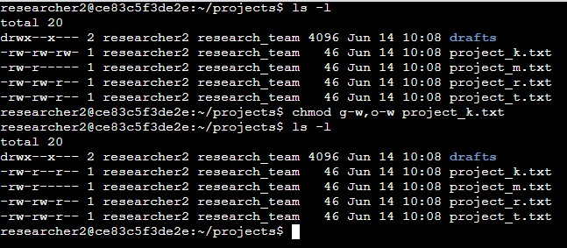

The first two lines of the screenshot display the commands I entered, and the other lines display the output of the second command. The chmod command changes the permissions on files and directories. The first argument indicates what permissions should be changed, and the second argument specifies the file or directory. In this example, I removed write permissions from other and group for the project_k.txt file. After this, I used ls -l to review the updates I made.

Change file permissions on a hidden file

In the project directory there is only one hidden file which is project_x.txt we need to change the write permissions for user and group and to change permissions for a hidden file the following linux command is –

(a hidden file is denoted with a (.) before the file name starts)

~/project$ ls –la

~/project$ chmod u-w,g-w,g+r project_x.txt

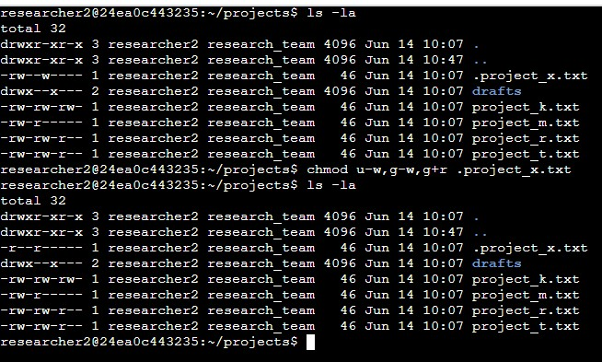

The first two lines of the screenshot display the commands I entered, and the other lines display the output of the second command. I know .project_x.txt is a hidden file because it starts with a period (.). In this example, I removed write permissions from the user and group, and added read permissions to the group. I removed write permissions from the user with u-w. Then, I removed write permissions from the group with g-w, and added read permissions to the group with g+r.

Change directory permissions

[Add content here.]

To change the permissions for the directory which is drafts directory inside the projects directory, we need to change the executable permission for the group, the following Linux command is –

~/project$ ls –l

~/project$ chmod g-x drafts

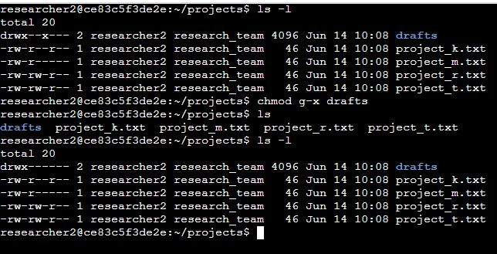

**Summary**

I changed multiple permissions to match the level of authorization my organization wanted for files and directories in the projects directory. The first step in this was using ls -la to check the permissions for the directory. This informed my decisions in the following steps. I then used the chmod command multiple times to change the permissions on files and directories.